FORM FOR RESPONSE TO ESA RT

Info Item Title Field | Value Field | Remark Field
RT Id |  | (Same as for RT)
Contractor Company Name | Aurora Technology B.V.
First Name
Last Name
Current Nationality
Other Nationality
Place of birth
Gender | Choose an item.
Date of birth
Notice Period | Choose an item.
TUD (planned) | Click here to enter a date.
Compliance Education |  | If No, please provide justification for proposing candidate
Compliance Experience |  | If No, please provide justification for proposing candidate
Number of years relevant experience | Choose an item.
Agreement by candidate of pre-contract and related working conditions
Date of Agreement | Click here to enter a date.
Family member at ESA |  | If Yes, please specify name, organisation code, status (staff/contractor) and relationship
Business interest with regard to ESA business |  | If Yes, please briefly summarise by attaching description of business interest as annex to this form.
Signature of the candidate |  | In accordance with the applicable data protection regulation, I hereby give my explicit consent to Aurora, the Contractor company and ESA to process my personal data contained in this document for the purposes of this Restricted Tender.  I hereby also authorize Aurora to store, use and process my personal details contained in this document.

CV OF PROPOSED PERSONNEL

PERSONAL INFORMATION

Title: Choose an item. | Surname:
First Name: | Date of birth:
City of birth: | Country of birth:
Present Nationality:
Do you require a permit to work at the location indicated in the vacancy?

EDUCATION

- Formal Education
 | Name and Location | From mm/yy | To mm/yy | Full-Time/Part -Time | Major Subjects | Degree or Diploma obtained
Secondary School/High school |  |  |  | Choose an item.
Choose an item. |  |  |  | Choose an item.
Choose an item. |  |  |  | Choose an item.
Choose an item. |  |  |  | Choose an item.
Choose an item. |  |  |  | Choose an item.
If required, additional diplomas can be described in the Area of Specialisation.

- Membership of Business Professional Associations, Professional Qualifications
Qualification Received | Awarded by | Subject | From mm/yy | To mm/yy | Date

- List of patents, publications and other significant work

- Languages
Mother tongue
Other languages | Speaking | Listening | Writing | Reading
English | Choose an item. | Choose an item. | Choose an item. | Choose an item.
French | Choose an item. | Choose an item. | Choose an item. | Choose an item.
 | Choose an item. | Choose an item. | Choose an item. | Choose an item.
 | Choose an item. | Choose an item. | Choose an item. | Choose an item.
*Please list languages in order of fluency and use as reference the Common European Framework of Reference (CEFR) table in Annex 1 to evaluate the candidate’s level.

- Area of specialisation
Please list here your areas of specialization and number of years of experience.
If applicable, add software skills or other relevant knowledge.
Use this section to summarise your skills against those required for the position.
If required, additional diplomas not listed in Section 1) can be described in this Area of Specialisation.

PROFESSIONAL EXPERIENCE

PRESENT EMPLOYMENT
Company:
Address:
Job title:
Name of Supervisor:
Employment from (mm/yy): | Employment to (mm/yy):
Total years/months of employment:
Description of duties and responsibilities:
Number of employees reporting to you:
Reason for leaving:

PREVIOUS EMPLOYMENT
Company:
Address:
Job title:
Name of Supervisor:
Employment from (mm/yy): | Employment to (mm/yy):
Total years/months of employment:
Description of duties and responsibilities:

Number of employees reporting to you:

Reason for leaving:

PREVIOUS EMPLOYMENT
Company:
Address:
Job title:
Name of Supervisor:
Employment from (mm/yy): | Employment to (mm/yy):
Total years/months of employment:
Description of duties and responsibilities:

Number of employees reporting to you:

Reason for leaving:

PREVIOUS EMPLOYMENT
Company:
Address:
Job title:
Name of Supervisor:
Employment from (mm/yy): | Employment to (mm/yy):
Total years/months of employment:
Description of duties and responsibilities:

Number of employees reporting to you:

Reason for leaving:

PREVIOUS EMPLOYMENT
Company:
Address:
Job title:
Name of Supervisor:
Employment from (mm/yy): | Employment to (mm/yy):
Total years/months of employment:
Description of duties and responsibilities:

Number of employees reporting to you:

Reason for leaving:

For previous employment, please indicate below:

MOTIVATION LETTER

<Insert motivation letter here>

This should include at least the following:
- Summarise your understanding of the position
- Highlight your experience that is relevant to the position
- Clarify why you would be good for the job
- Explain why this position is interesting to you
- State your interest to work in English at ESA in an international environment.
It should be addressed to ESA rather than Aurora and can start To whom it may concern,

Annex 1:
Common European Framework of Reference for Languages

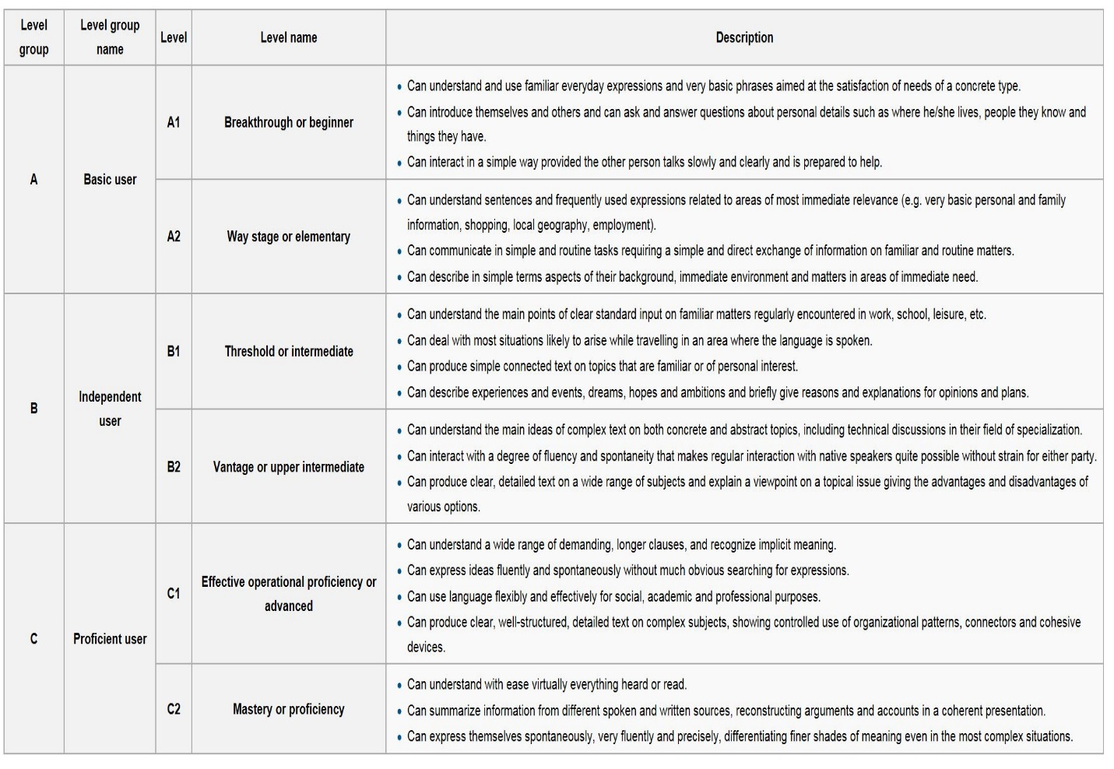

The following sections are for Aurora and not provided to ESA:

9. RESIDENCE
Present address (to which correspondence should be sent):
Home address (if different from above):
TELEPHONE / E-MAIL:
Home Tel:
Home E-mail:
Business Tel: |  | Can we call you at your office? | NO |  | Yes
Business E-mail:
Mobile Tel:
Skype ID:

10. REFERENCES
We MUST receive at least 3 references before we can issue a letter of employment.
Provide contact details of at least 3 people who you authorise us to contact to obtain these references.

Name | Position | Address | Contact Details

11. AVAILABILITY
End date of existing contract
Do you have a clause relating to working for a competitor in either your current position or any employer for whom you have worked in the last year? If so please detail

GDPR Compliance Statement:
By filling and providing this document, the candidate authorizes Aurora to store, use and process personal details contained in it as defined inside Aurora’s Recruitment Privacy Policy.

Please indicate total years/months of employment acquired until you submitted your application for this RT.

